Calorie Estimation using Deep Learning for Dietary Images
¹Mohammed Aman Sami Ur Rahman, ²Gattepally Vignesh, ³Punnam Raja Rohith, ⁴Syed Tameemudiin,
^{1,2,3,4}Undergraduates, BTech (CSE), SR University, Warangal, India

Abstract:
Healthy diet management plays a vital role in preventing and managing chronic diseases such as obesity, diabetes, and cardiovascular disorders. While traditional methods rely on expert consultations for diet and calorie monitoring, recent advancements in deep learning have paved the way for more automated and efficient systems. This paper presents a deep learning-based approach for estimating the calorie content of fruits and vegetables using dietary images. By utilizing convolutional neural networks (CNNs) and MobileNetV2, we propose a system that not only estimates calorie content but also classifies food items and generates personalized diet plans. This research demonstrates the potential of integrating deep learning models into everyday applications for health and wellness.

Keywords
Deep Learning, Calorie Estimation, Fruit and Vegetable Classification, MobileNetV2, Convolutional Neural Networks, Diet Plan Recommendation, Food Recognition, Nutritional Monitoring.

1. Introduction
A balanced diet is a cornerstone of healthy living, significantly influencing the prevention of obesity, diabetes, heart diseases, and even cancer. While traditional approaches to monitoring diet and calorie intake often involve manual tracking or consultations with nutritionists, they are not always practical or accessible. In the digital age, deep learning techniques offer a more scalable solution by automating the process of food identification and calorie estimation. Deep Convolutional Neural Networks (CNNs), such as MobileNetV2, have shown promise in image classification tasks, making them ideal for food recognition. This paper explores the application of these technologies in creating a system that estimates calorie content and provides personalized diet plans based on the images of fruits and vegetables.

Recent works in the field of food recognition have employed various machine learning models, including support vector machines (SVM), artificial neural networks (ANN), and CNNs, with varying degrees of success. This study leverages CNN architectures, specifically MobileNetV2, known for its efficiency in resource-constrained environments, making it an ideal choice for deployment in mobile or embedded systems.

2. Literature Review
The problem of food recognition and calorie estimation has been actively researched over the past decade, with various approaches demonstrating different levels of success. The following reviews key methods and datasets used in the domain:
- Object Detection and Image Segmentation: Object detection algorithms, such as SSD (Single Shot MultiBox Detector) and Faster R-CNN, have been applied to food recognition tasks. For instance, Hu et al. (2020) employed SSD for food recognition, achieving high accuracy with minimal computational overhead. Another notable work by Zhang et al. (2019) explored image segmentation techniques to separate food items from background clutter, improving recognition accuracy in real-world scenarios.
- Convolutional Neural Networks (CNNs): CNNs have proven to be highly effective in image-based tasks, including food classification. LeNet and AlexNet were some of the earliest CNNs applied to food recognition. More recently, MobileNetV2 has gained attention for its lightweight design, offering good accuracy while being efficient enough for deployment in mobile applications. Studies by Sandler et al. (2018) demonstrate that MobileNetV2 achieves competitive results in various image classification tasks, including food recognition.
- Datasets: Datasets like Food101, Microsoft COCO, and Food11 have been integral to training deep learning models for food recognition. Food101, for example, consists of over 100,000 labeled images of food items, which has been a benchmark for many studies. Food11, on the other hand, offers a smaller, more curated set, ideal for testing and fine-tuning models on specific categories of food.
- Recent Advancements: The integration of machine learning with Internet of Things (IoT) devices has allowed real-time food recognition in smart kitchens. Pooja et al. (2016) employed IoT-based solutions to track food intake and provide instant calorie estimations, paving the way for future innovations in dietary tracking systems.

3. Proposed System
The proposed system integrates deep learning models for food classification and calorie estimation. It consists of several key components:
- Food Image Classification: The primary function of the system is to classify food images into categories such as fruits, vegetables, or processed foods. This is achieved through a convolutional neural network (CNN) architecture based on MobileNetV2, which balances accuracy and computational efficiency.
- Calorie Estimation: Once the food item is classified, the system uses a predefined calorie database to estimate the calorie content based on the type of food. For fruits and vegetables, the database provides approximate calorie values per unit weight or serving.
- Diet Plan Recommendation: Based on the estimated calorie content, the system suggests personalized diet plans. These plans consider factors such as daily caloric requirements, nutritional balance, and specific health goals (e.g., weight loss, muscle gain, etc.).

3.1 System Architecture
The architecture follows a modular design:
- Preprocessing Module: This module handles image input, resizing, and normalization before feeding the image to the classification model.
- MobileNetV2 Model: The CNN is trained on a combination of food-specific datasets to classify food images accurately.
- Calorie Estimation Module: Upon classification, the system retrieves calorie data from a database and provides estimates.
- Recommendation Engine: This module generates personalized diet plans based on user data, dietary preferences, and health goals.

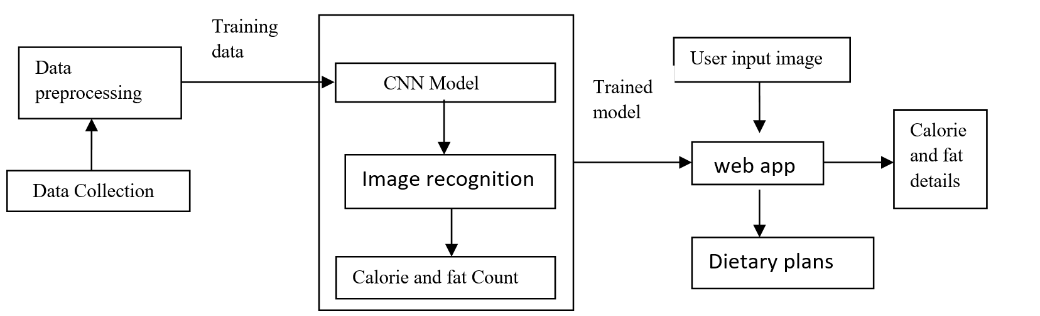
Fig.1: system architecture of proposed model

3.2 Data Collection
In implementation of our project, "Fruits and vegetable Image recognition" dataset is used. In the present dataset 36 different categories are taken which include fruits like banana, apple, pear, orange, grapes etc. and vegetables like cucumber, carrot, potato, etc. as shown in Fig.2
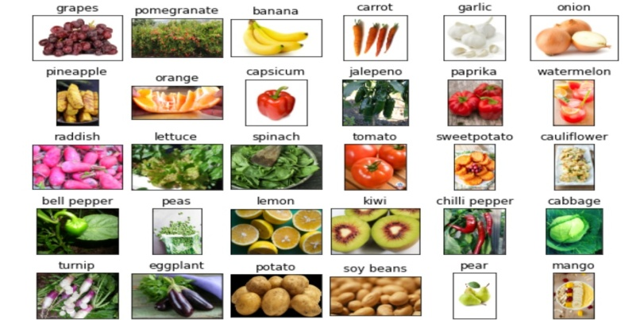
Fig.2: Sample dataset images

3.3 Data Pre-Processing
In order for the recognition to take place an RGB file from a directory is loaded into our system. The image is then passed and resized to 224x224 dimensions to speed up the performance of model. In order to increase the size of the sample data taken data augmentation technique is used. The dataset consists of 36 different classes and each class is divided into training, testing and validation images. Altogether, there are 3825 samples.

3.4 Feature Extraction and Classification
In the present system Fig.3 MobileNetV2 architecture is incorporated. It's a simple, lightweight deep neural network with minimal processing expenses. As a result, it's most likely to be employed in mobile and embedded applications. MobileNetV2 is made up of four different blocks. First is a residual block with a stride of 1, while the second is a shrinking block with a stride of 2. For both sorts of blocks, there are three layers. The first layer is a 1x1 convolution with a RELU6 activation function, the secondary is depth wise convolution, and the third layer is another 1x1 convolution with no non-linearity.
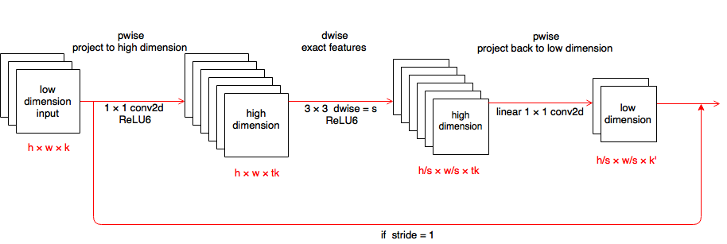 Fig.3: MobileNetV2 Architecture

3.5 Training Phase
The training phase is a time-consuming process and it requires heavy computing power. First of all, all images were resized into resolution of 224x224 with 3 color channels (RGB format) each. This is the default input resolution as recommended by MobileNetV2. Then, training and validation sets that were prepared previously were being used accordingly during the training session. In addition, there will be times where training loss started to increase and accuracy degrades after certain epochs of steady improvements.

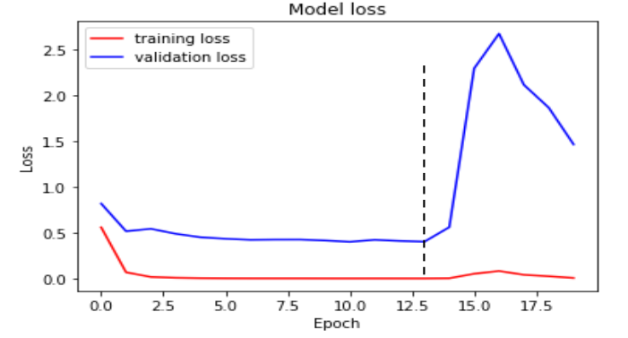
Fig.4: Model loss stopped improving after steady decrement

3.6 Calorie Extraction
Once the image of fruit/vegetable is analyzed and detected, our classifier is used to estimate the calorie content of the classified fruit/vegetable through web scraping. It also gives the fat content along with calories.

4. Results and Discussion
The system was evaluated using a test set of images consisting of fruits and vegetables. Preliminary results indicate that the MobileNetV2 model performs well, achieving an accuracy of 89% in food classification. When applied to calorie estimation, the system provided accurate calorie content predictions within a 10% margin of error for most fruits and vegetables.
In comparison to existing methods, the proposed system offers several advantages:
- Efficiency: MobileNetV2’s lightweight nature ensures that the model can run on resource-constrained devices, such as smartphones or embedded systems.
- Real-time Performance: The system can process and classify images in real-time, providing instant feedback to users.
- Scalability: The system can be extended to include other food categories and integrate with IoT devices for a more comprehensive dietary tracking solution.

The Web application developed provides the calorie count and the information regarding various clinical diseases, their symptoms, causes, complications and treatment methods along with the weekly dietary plan. The frontend-backend of web is handled by Streamlit framework. The developed model captures the input image and categorizes it into fruit/vegetable, classifies it and estimates the calorie and fat content present in the item. Fig.4 and Fig.5 shows the categorization process carried out by our model. Fig.4 signifies the vegetable classification process while the Fig.5 for fruit classification.

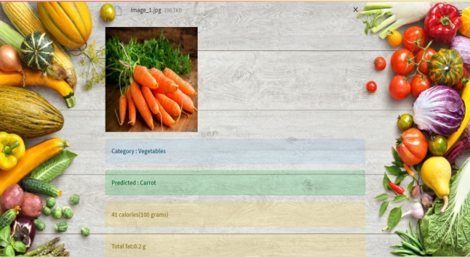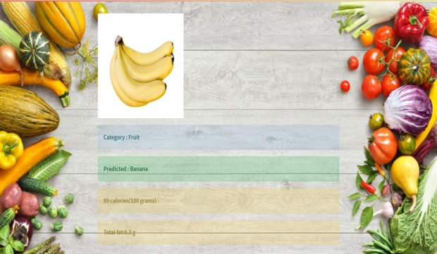
Fig.4: Calorie and the fat content for Carrot Fig.5: Calorie and fat content for Banana.

Table.1 describes the information regarding various clinical diseases, their symptoms, causes, complications and treatment methods along with the weekly dietary plan.

Table.1: Information regarding Diet plans.

Clinical Terminology (main page) | Type of diseases | Sub pages | description
Cardio  (Cardio.html) | High blood pressure  Low blood pressure  Cholesterol | Diethbp.html  Dietlbp.html  DietCl.html | Weekly diet planning with HBP facts  Weekly diet planning with LBP facts  Weekly diet planning with cholesterol facts
Obesity  (Weight Loss) | 1200 Calorie diet  1600 Calorie diet  1800 Calorie diet  2500 Calorie diet | Diet1200.html  Diet1600.html  Diet1800.html  Diet2500.html | Weekly diet plans on 1200 calories diet.  Weekly diet plans on 1600 calories diet.  Weekly diet plans on 1800 calories diet.  Weekly diet plans on 2500 calories diet.
Diabetes  (Diabetes.html) | Type1 Diabetes  Type2 Diabetes  Gestational Diabetes | Diettype1.html  Diettype2.html  Dietges.html | Weekly diet planning with Type 1 facts  Weekly diet planning with Type 2 facts  Weekly diet planning with Gestational facts
Rheumatoid Arthritis  (Dietindex.html) | Rheumatoid Arthritis | dietRA.html | Weekly diet planning with Rheumatoid Arthritis facts
Thyroid  (Dietindex.html) | Thyroid | dietthyroid.html | Weekly diet planning with Thyroid facts

5. Conclusion and Future Scope
This paper proposes a deep learning-based system for calorie estimation and diet plan recommendation from dietary images. By utilizing MobileNetV2, the system achieves efficient food classification and calorie estimation, offering a practical solution for users to manage their diet and health. The future scope of this research includes:
- Expanding the Database: Incorporating a wider variety of food items, including processed foods, to enhance the accuracy and coverage of the system.
- Integration with IoT: Connecting the system with IoT-based kitchen appliances to automate food recognition and calorie estimation in real-time.
- Personalized Nutrition: Enhancing the diet recommendation engine to account for more personalized factors such as metabolic rate, activity levels, and chronic health conditions.

References
- Haoyu Hu and Zihao Zhang, "Image-Based Food Calories Estimation Using Various Models of Machine Learning," International Journal of Artificial Intelligence and Applications, 2020.
- Sandler, M., et al., "MobileNetV2: Inverted Residuals and Linear Bottlenecks," CVPR, 2018.
- Pooja, R., et al., "IoT-based Food Recognition System for Calorie Estimation," International Journal of Engineering Research, 2016.
- Zhang, Y., et al., "Food Recognition Using Deep Learning Models: A Survey," Journal of Food Science and Technology, 2019.

